Structural Analysis using Finite Element Method

Objective:
To analyze deformation and stress in a rectangular beam using Finite Element Analysis (FEA).

Software Used:
ANSYS Workbench

Methodology:
A rectangular beam model was created. One end of the beam was fixed, and a force was applied at the opposite end. The simulation was performed to evaluate deformation and stress distribution.

Results:
- Maximum Deformation: 1.93 mm
- Maximum Stress ≈ 9.96 × 10^7 Pa
- Maximum stress occurs near the fixed support
- Maximum deformation occurs at the free end
Figures:
(Figure 1: Deformation Result)
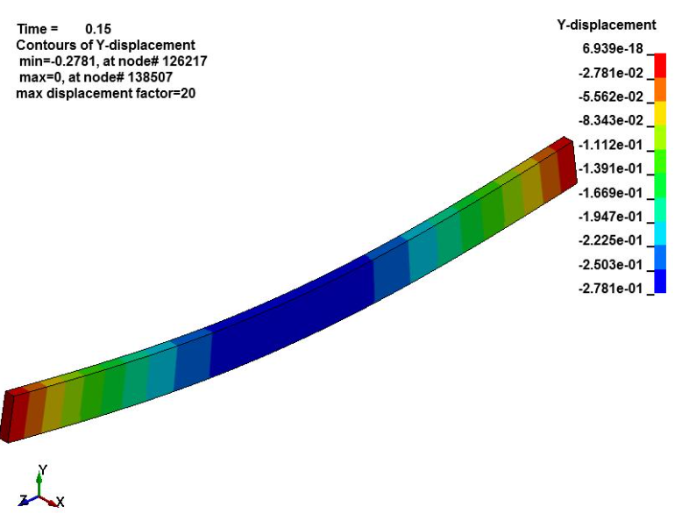

(Figure 2: Stress Result)
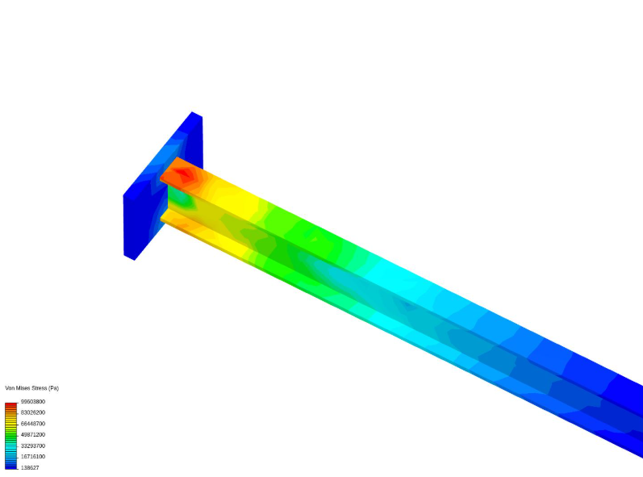

Conclusion:
The simulation results show that the beam experiences maximum stress near the fixed end and maximum deformation at the free end. The structure behaves correctly under applied load, validating the simulation.

